## [primefaces]trigger ajax doesn't need trigger BlockUI

Shared by: Gilbert Lin

Problem:

**若點選checkbox(例如廠別)使用ajax效果,會出現處理中小視窗**

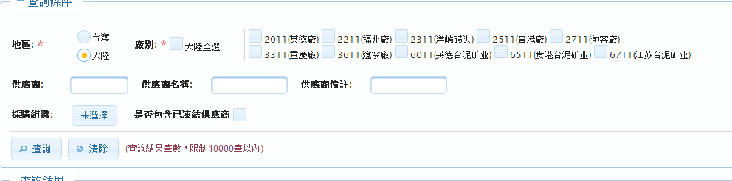



**Solution:**

**若不想出現處理中小視窗,讓global屬性為false**

**<p:ajax immediate="false" global="false"**

**Ref:**

<http://forum.primefaces.org/viewtopic.php?f=3&t=18125>